
DHARMSINH DESAI UNIVERSITY, NADIAD
FACULTY OF MANAGEMENT AND INFORMATION SCIENCE
B.C.A. SEMESTER VI
SUBJECT: (25BCA601)SYSTEM DEVELOPMENT PROJECT
Student Name | Himanshu D Ladha
Roll No | BCA045
Student ID | 23BCUOS055

Project Definition: RestoFlow – A full-stack Restaurant Management Platform.

Company Timing: 11:00 AM to 6:00 PM

Week | Date | Day | Name of the Topic | Signature
Seventh Week | 12-01-2026 | Monday | UI Enhancement
Seventh Week | 13-01-2026 | Tuesday | Theme Customization
Seventh Week | 14-01-2026 | Wednesday | --Holiday--
Seventh Week | 15-01-2026 | Thursday | --Holiday--
Seventh Week | 16-01-2026 | Friday | Bugs Fixes

External Guide Name: Somil Sir Internal Guide Name: Prof. Rupal Patel
Signature Signature

12-01-2026
- Improved the overall user interface of the project to enhance visual appeal, readability, and provide a clean, modern user experience.
13-01-2026
- Implemented a Dark Mode theme toggle feature.
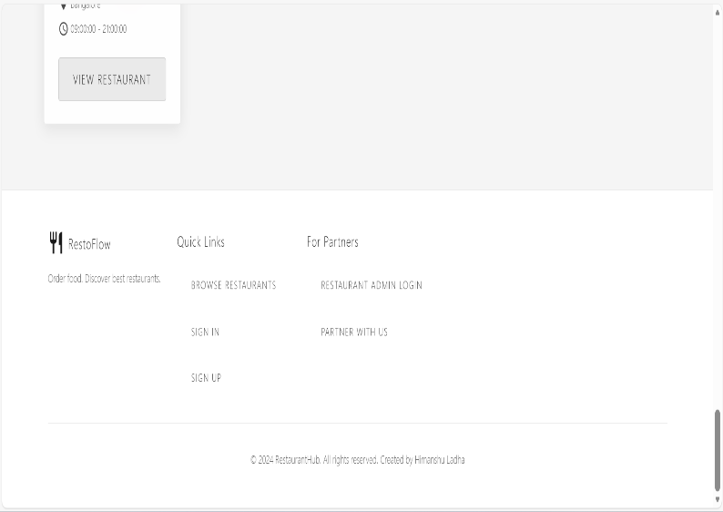
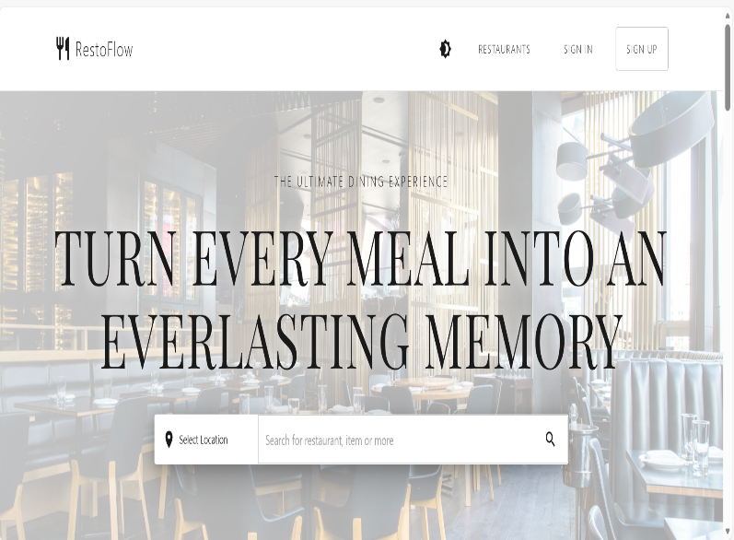
- Enabled seamless switching between light (white) and dark (black) themes across the website for better user accessibility and comfort.

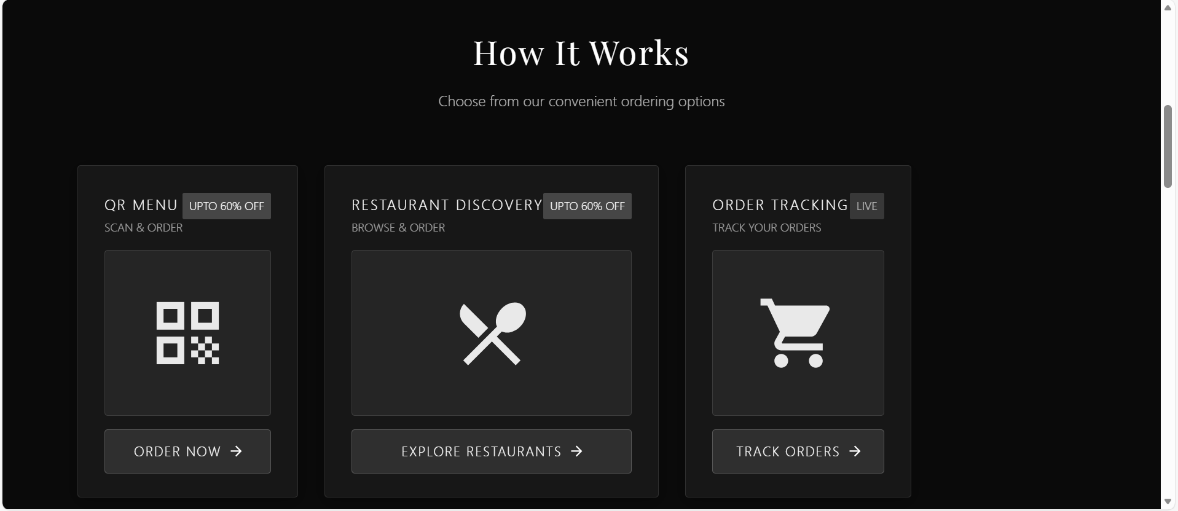
16-01-2026
- Solve the issues that is arriving at the customization in the theme toggle.
- In some part the color visibility issue where there in dark mode that solve.

